RabbitMQ on Cloud

* Register an account:

Register an account on this website [https://www.cloudamqp.com](https://www.cloudamqp.com/)

* Navigate account details

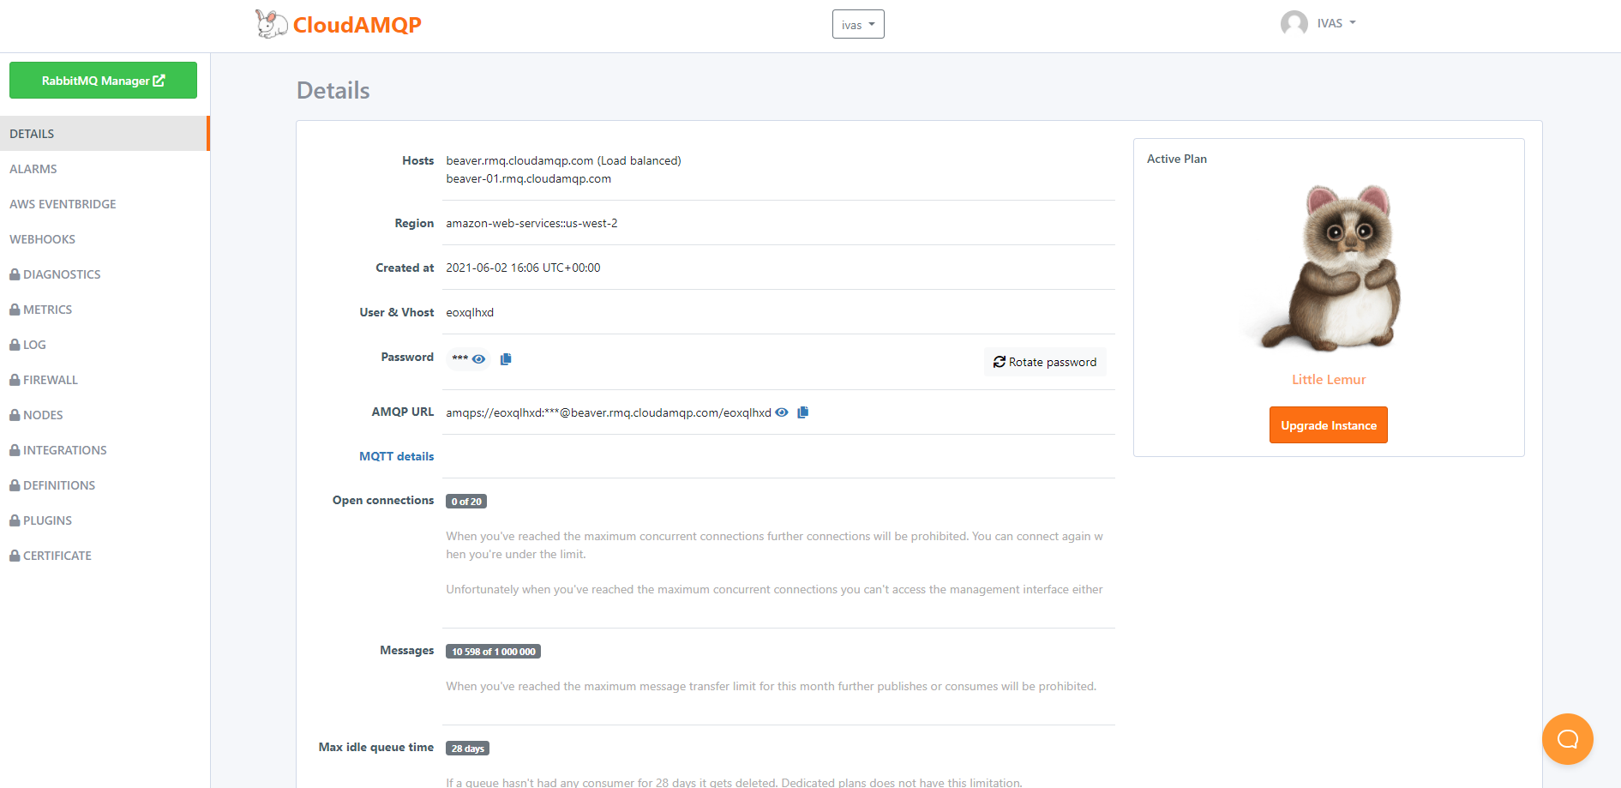

* RabbitMQ Manager

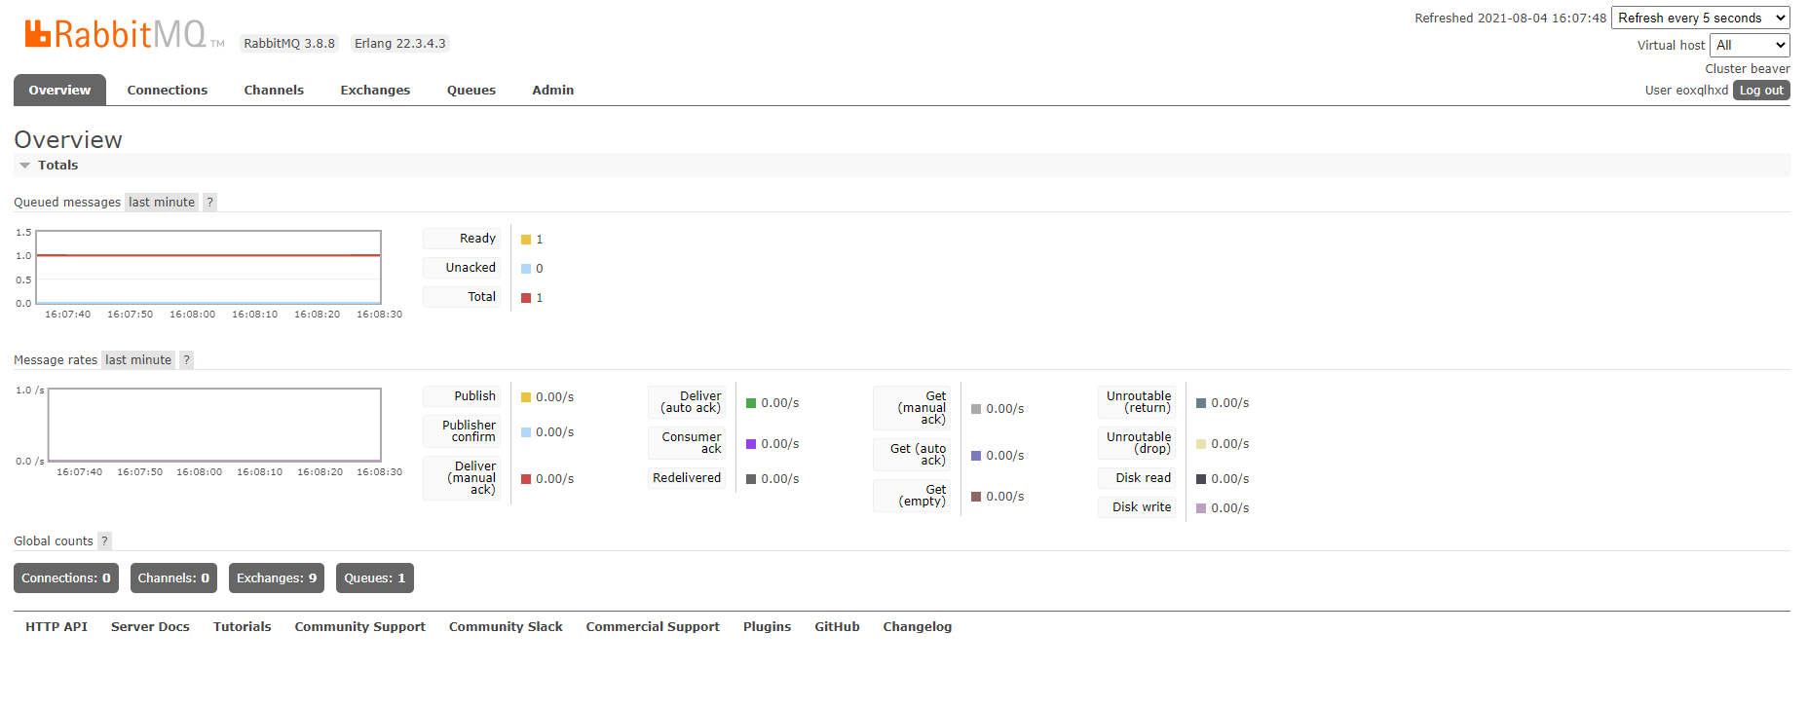

* RabbitMQ Windows Monitor

You can watch message send and received to RabbitMQ by observe the overview section

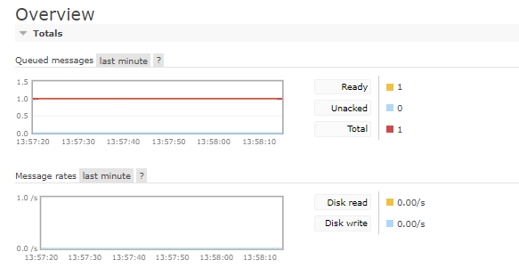

* RabbitMQ Windows Default Configuration for Laravel

You can get laravel cradintials in the cloud from hme page details

